Assistant Coach

Mobile Application

1. **Introduction**
   1. Assistant Coach is a mobile application that will aid little league coaches and other youth leaders with organization and communication. Assistant coach will initially focus on little league baseball coaches but the application will be scalable to work with any sport and even non-sports activities.
2. **Project Goal and Objectives**
   1. **Overall Goal**
      1. The goal of Assistant Coach is to provide a simple and quick mode of communication between coaches, players, and parents. This application will give coaches an organizational tool where they can store player contact information and track statistics and player performance.
   2. **Specific Objectives**
      1. Little league baseball coaches have the heavy task of organizing nine or more young athletes into a manageable baseball team for the summer. This involves setting practice times and making sure parents know when to take their kids to practices and games. Little league baseball coaches also have to keep track of important statistics like playing time of players, pitch count for pitchers, and unique abilities and strengths of certain players. This application makes the difficult task of coaching a little league team more manageable.
   3. **Specific Features**
      1. Player Profile
         1. Name
         2. Age
         3. Contact Information(Player and Parent optional)
         4. Positions
         5. Strengths
            1. Speed
            2. Power hitter
            3. Contact hitter
            4. Good glove
            5. Good arm
         6. Statistics
            1. Batting Average
            2. Innings Played
            3. Innings Pitched
      2. Send message
         1. Sends message to all players or parents
      3. Set lineup
         1. Set the starting lineup for a game
      4. Enter schedule
         1. Enter practice schedule
         2. Enter game schedule
      5. Parent/fan view
         1. Parents can sign in to a specific view of the app
            1. Cannot make changes to team
            2. View schedule
            3. View player statistics (if coach makes them visible)
            4. View lineup
   4. **Significance**
      1. There are many apps that provide group chat or mass communication to users. There are also apps that can track statistics for a sport. This app is unique, however, because it provides all of these features in one place. This app will also provide a unique experience to parents and fans because they will be able to see the changes that the coach is making to the team.
3. **Project Plan**
   1. **Schedule**
      1. 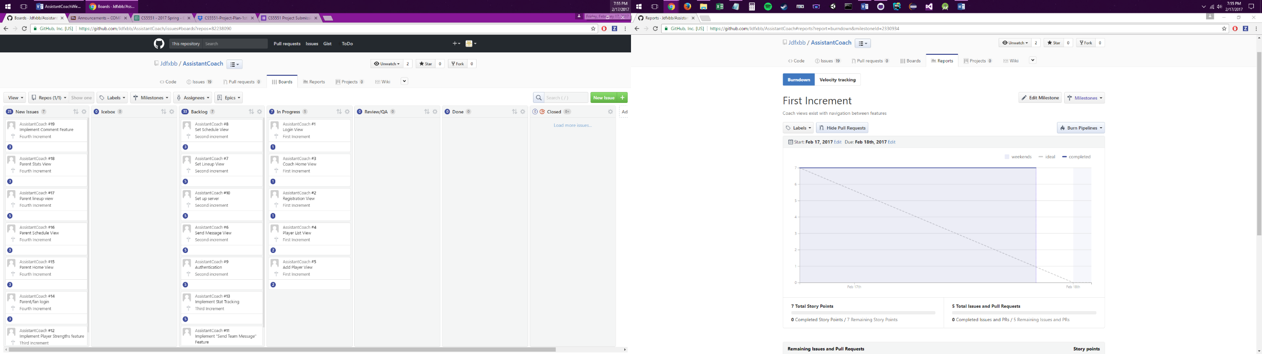**Stories**
   2. **Project Timelines, Members, Task Responsibility**
      1. Increment I 17 February 2017
         1. Login View: Joshua
            1. The coach can login to the app
         2. Coach Home View: Mark
            1. The coach can see a home view with buttons to the features
         3. Registration View: Bilal
            1. The coach can register if he/she is a new user
         4. Player List View: Joshua
            1. The coach can view a list of players
         5. Add Player View: Mark
            1. The coach can add players to the team
      2. Increment II 10 March 2017
         1. Set Schedule View: Bilal
            1. The coach can set practice times and game times
         2. Set Lineup View: Joshua
            1. The coach can set the lineup for a game
         3. Server: Joshua
            1. The coach can make changes to the team and they are saved on a server
         4. Send Message View: Mark
            1. The coach can send a message to his team via email API
         5. Authentication: Bilal
            1. The coach can sign in with email, Google+, or Facebook
      3. Increment III 7 April 2017
         1. Strengths Feature: Mark
            1. The coach can select strengths of certain players based on their ability
         2. Stat Tracking: Bilal
            1. The coach can enter the stats for a game and view aggregate stats for a season or multiple seasons
         3. Lineup Suggestions Mark
            1. The coach can see a suggested lineup based on stat history
         4. Google Conversation API Joshua, Bilal
            1. User can listen to the new chat messages from the team using conversation API and can know about the players in the team and their respected roles.
            2. User is able to ask questions regarding the team using google conversation API.
      4. Increment IV 26 April 2017
         1. Parent login: Joshua
            1. The parent can login to the app
         2. Parent Home View: Mark
            1. The parent can access a home view with buttons to different features
         3. Parent schedule view: Bilal
            1. The parent can view the team schedule
         4. Parent lineup view: Joshua
            1. The parent can view the lineup for a game
         5. Parent stats view: Mark
            1. The parent can view statistics for players
         6. Comment feature: Bilal
            1. The coach can make comments on the progress of players
            2. The parent can view comments on their child
         7. Run the trained agent on Google Home. Mark, Joshua
            1. User is able to send a message to the team via Google Home.
            2. (Optional) Coach is able to set the team lineup via google home.
   3. **Burndown Chart**
4. **First Increment Report**
   1. **Existing Services**
      1. Google Gmail API
      2. Android Studio
      3. Visio
   2. **Detail Design of Features**

      

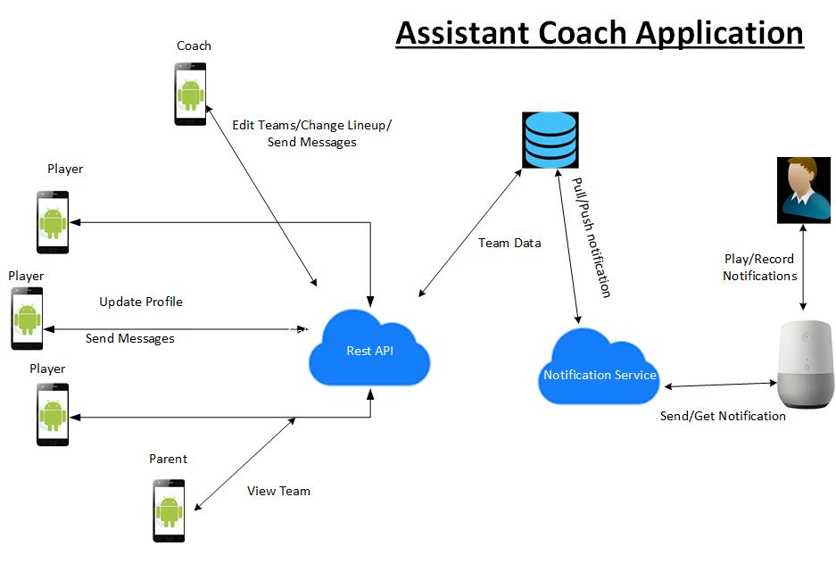**d. Architecture Diagram**